Andrew Fales

BIT 275

Assignment 3

1. Conceptual Data Model

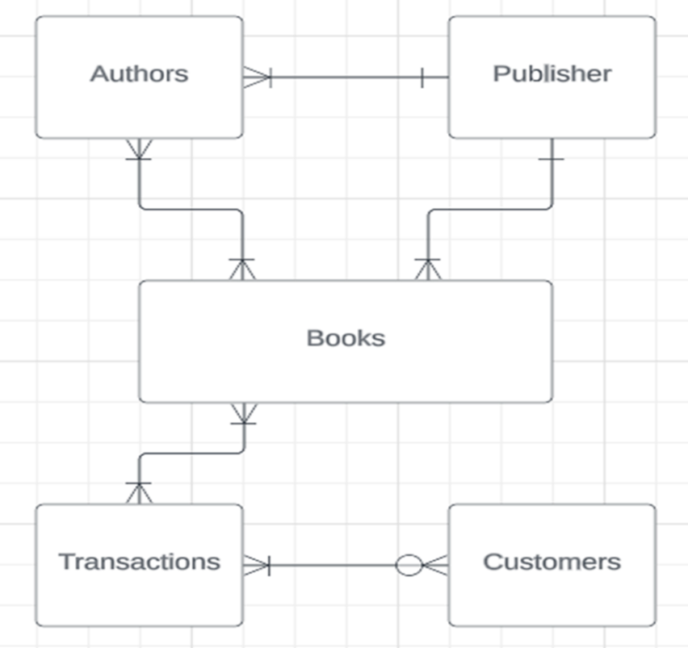

1. Physical Data Model / Database Creation Diagram

1. **Sample Queries**

Pulls the best selling genre from a certain date range (In this case May 2023)

* SELECT genreName, (SELECT MAX(quantity) FROM Transactions WHERE transactionDATE BETWEEN '2023-05-01' AND '2023-05-31') AS 'Quantity' FROM BookGenres

WHERE genreID =

(SELECT genreID FROM Books WHERE bookID =

(SELECT bookID FROM Books_Transactions WHERE transactionID =

(SELECT transactionID FROM Transactions WHERE quantity =

(SELECT MAX(quantity) FROM Transactions WHERE transactionDATE BETWEEN '2023-05-01' AND '2023-05-31'))));

Pulls genre from a specific book

* SELECT genreName FROM BookGenres WHERE genreID = (SELECT genreID FROM Books WHERE BookTitle = 'Book 1');

Pulls number of books authored by a specific author

* SELECT COUNT(DISTINCT bookID) AS 'NumBooks' FROM Authors_Books WHERE authorID =

(SELECT authorID From Authors WHERE authorFirstName = 'John' AND authorLastName = 'Smith');

Pulls the publisher name for a specific author

SELECT publisherName FROM Publisher WHERE publisherID =

(SELECT publisherID FROM Authors WHERE authorFirstName = 'John' AND authorLastName = 'Smith');

(I could go on and on with more queries but I think you get the idea. The table design allows for looking into inventory from specific parameters such as title, publisher, author, genre etc.)